Henry Post

ITMS 428

Damn Vulnerable Web Applications

Contents

**No table of contents entries found.**

# Setup

1. Install Linux, or any distro supported by Docker.
   1. I installed Ubuntu. This will work on a VM.
2. [Install Docker](https://docs.docker.com/install/linux/docker-ce/ubuntu/).
3. Run docker run --rm -it -p 80:80 vulnerables/web-dvwa.
   1. This command deletes any existing dvwa install.  
        
      To run your existing one, use docker start –i [container_name].
4. Due to a bug in MySQL requiring aufs, MySQL server doesn’t work on Docker sometimes. To fix it, either see [this link](https://github.com/ethicalhack3r/DVWA/issues/240) or follow the below steps.
   1. Open a new terminal.  
      Do not close the terminal with Docker running in it.
   2. 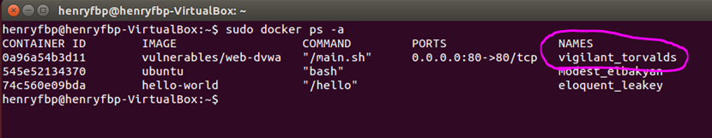Run docker ps –a to get a list of running containers. Note the name of your container.  
        
      Run docker exec -ti [container_name] /bin/bash to open a shell on your docker image.
   3. Run chown -R mysql:mysql /var/lib/mysql /var/run/mysqld to change permissions on the MySQL files.
   4. Run service mysql start to start the MySQL service.
5. It’s installed!  
     
   Visit 127.0.0.1:80 to visit the DVWA webserver.